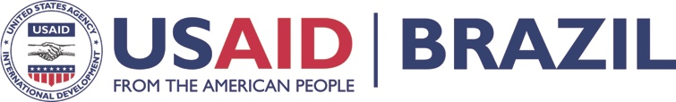

MONTHLY NEWSLETTER
PARTNERSHIP FOR THE CONSERVATION
OCTOBER 2017
OF AMAZON BIODIVERSITY (PCAB)

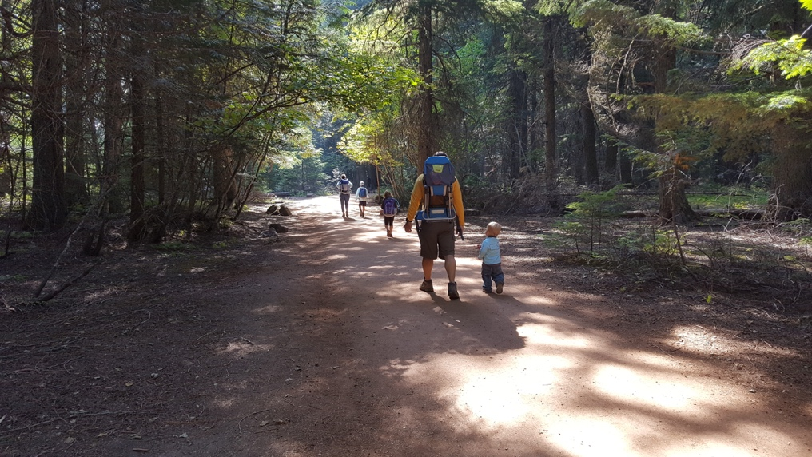
TECHNICAL EXCHANGE ON PROTECTED AREA MANAGEMENT HELD IN THE UNITED STATES
Photo: João da Mata
The US Forest Service created a unique technical exchange between the U.S. and Brazil last month when the project designed an intensive visit to share how resources on U.S. public lands are used and managed. They brought together ICMBio’s Sustainable Use and Protection Coordinator, João da Mata, and FUNAI’s General Coordinator for the Promotion of Ethnic Development, Juan Scalia, to experience a mosaic of Protected Areas (PAs) in the western state of Montana comprising the Flathead Indigenous Land, the Glacier National Park and the Lolo National Forest, where sustainable value chains were highlighted.
Citizens in the USA use the parks and participate in management planning
Both participants highlighted the “structure, team management and organization” of the US Forest Service (USFS). “After my return to Brazil, I kept dreaming about the trip for three days, and looking for ways to apply those ideas here”, says Da Mata.
Despite the significant differences between U.S. PAs (national parks, national forests) and Brazilian PAs in terms of structure and budget, the most impressive aspect for the Brazilian officials was the engagement with society and the number of people occupying U.S. PAs. According to Da Mata, “People visit these areas, they fish and hunt there, and they also participate in management planning activities. The director of the Glacier National Park, which welcomes around 3 million visitors per year, told us that one of the main challenges is to manage these visits. Their interest in providing a good service is wonderful, including ensuring users’ safety and satisfaction.”
For him, “the excellence in services delivery is admirable, with a focus on customers, who will benefit from the services, but who also then actively participate and help with the park planning. This is a challenge for us: engaging society to manage our Pas, together with us. We understand that this is fundamental”.
“You go to a National Park that has walking and cycling trails, places to ski in the winter, to hunt, etc. It is well organized, well supported by the government and has a considerable budget comparing with Brazil, as well as more human resources. And all of this has an economic return, as visitors bring more resources to the local economy”, adds Scalia. He sees the potential for Brazil, highlighting the benefits of bringing together common interests around public policies, private investment, a society that demands services, and, in the specific case of indigenous peoples, the autonomy of Indigenous Territories in Brazil to propose their own development processes.

The US Forest Service is a lot older, better structured and richer than its Brazilian counterparts. Its 35,000 staff manage 77 million hectares, while at ICMBio, 1,700 staff oversee 80 million hectares. For Scalia, it is not about copying the American model, but learning from their experience and seeing what can be applied well in Brazil. “We visited the Confederated Salish and Kootenai Tribes, which are two indigenous ethnicities that are jointly responsible for organizing the visitation to the largest lake in the region, in the west of the USA, inside their indigenous lands. They charge an entrance fee, accredit boats that sail on the lake, and coordinate the environmental licensing of small piers. They issue the licenses, charge the fees and manage the resources themselves. The US Government delegates this authority to them”.
Although the experience is somehow far from the Brazilian reality, Scalia points out that other countries in the continent, such as Colombia and Ecuador, are following a similar path. “In Brazil, we still have areas to be demarcated and others in the process of demarcation, but 13% of Brazil is under indigenous management and it is important to improve our Territory and Management Planning. It was interesting to see, during the visit, how people can get organized as constituents of a local government. Minor changes in our national legislation toward this type of recognition could lead us to an interesting solution”.

“The visit was very positive, as we could understand the logic behind a very integrated mosaic”, said Scalia. Integrating land management among Indigenous Lands, National Parks and National Forests enables interaction and partnerships. “For example, a well-organized National Park visitation scheme also supports visits to Indigenous lands”, he adds.
Collaboration
They were also able to see how North-Americans deal with land conflicts, including the existence of sacred indigenous venues outside the Indigenous Reservations. “The approach to law enforcement in the United States, even when decisions are not favourable to indigenous peoples, has helped solve many conflicts over the past decades. Impunity takes place in Brazil at different levels, and tends to exacerbate conflicts”, he stresses.
Under the PCBA, FUNAI and ICMBio have been working together on specific productive chains: Brazil nuts, pirarucu and açaí. Some ideas, including market studies and expanding cooperation between ICMBio and FUNAI, are ongoing and being strengthened.
At FUNAI, the recent regulation of tourism in Indigenous Lands will enable the development of a demonstrative site together with the US Forest Service. “With the program funds [USAID’s funding for USFS], we are planning some workshops next year focusing on value chains, tourism, fire management and degraded areas”, says Scalia.
All these topics are linked to the land management policy in Indigenous Lands. “We do not want to import a model, but rather to identify applicable ideas and inspiration. We are trying to find an existing experience of tourism carried out by Indigenous, which could involve the Yanomamis, where there is an overlap with a National Park (Pico da Neblina).”.
Scalia and Da Mata agree that it is necessary to advance how value chains, use of natural resources, and tourism, are structured. Methodologies and lessons learned from the US Forest Service serve as inspiration. “We can learn a lot from the United States in this field of business”, says Scalia.

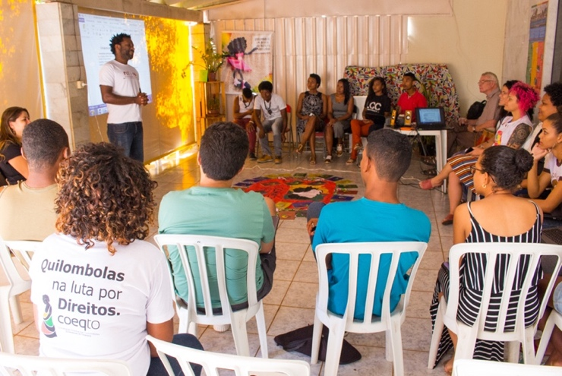
GOOGLE EARTH AND ODK TECHNOLOGIES PROVIDE GREATER OPTIONS TO TRADITIONAL COMMUNITIES TO MANAGE THEIR TERRITORIES
Photo: Archive ECAM
There are over 5,000 Quilombola (African-Brazilian descent) traditional communities in Brazil which, under the Constitution, have land rights to their territories. Yet, in practice few of these communities have their land tenure formally recognized and in many cases, their territories are not even mapped. Despite that, Quilombola communities have demonstrably lower rates of deforestation than surrounding areas. Providing digital tools such as Google Earth and Open Data Kit (ODK) helps them better manage their land, and strengthens their rights over that land by providing them with a concrete map of the territory. One of USAID’s projects, a public-private partnership with Google Earth Outreach and ECAM, a local Brazilian NGO, supports capacity building of traditional peoples with innovative technologies.
Opening of the workshop in Brasília
ECAM is collaborating with the National Coordination for the Articulation of Rural Quilombola Communities (CONAQ) to provide digital tools to Quilombo youths from throughout the Brazilian Amazon region. On October 19-21, ECAM and CONAC organized a workshop for 20 Quilombo youths from the states of Tocantins and Mato Grosso.
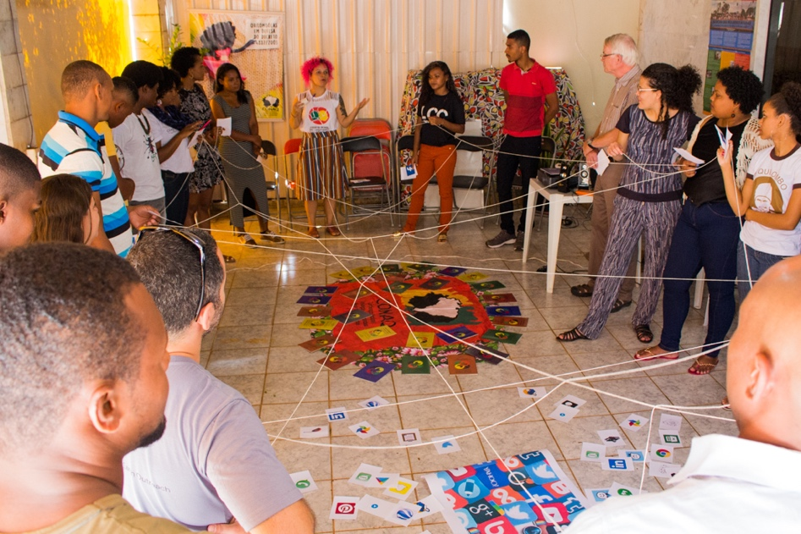
Google Earth and ODK are free and user friendly technologies. These characteristics permit Quilombos and other traditional communities to carry out surveys and systematize information about their reality. Google Earth is a program installed in a computer or notebook. It enables the user to access images, roads, borders and other data that facilitate mapping. The communities that use Google Earth can insert information about their territory, such as cultural elements, infrastructure, and land uses (hunting, fishing, farming, etc.). All of this information can produce a Cultural Map made directly on Google Earth by local communities, thereby empowering them to gain greater control over their territories.
Youngsters will be able to collect socioeconomic data in their communities
Photo: Archive ECAM
ODK enables users to carry out, on smartphones or tablets, surveys and organization of data. On ODK it is possible to construct questionnaires, collect information in the field and organize the data in ways that are appropriate for visualization. Depending on the needs of each community it is possible to collect information about socioeconomic conditions, invasions of protected areas, or quantities of agricultural or forestry production, for example.
A highlight of the training was a portion given on YouTube with Allan Portes, from the Pixel Tutorial channel. YouTube could be an additional tool to help preserve traditional knowledge, as well as a means for young people to post their own videos to a global audience and tell their own stories.
According to Evandro Moura Dias, CONAQ’s Youth Coordinator, the most important thing is to be able to take these tools back to the community. “We already work with cartographic mapping, and attending this program has expanded our horizons. These tools are more accessible for me and the community, and they can give us a new perspective”.

Walking the talk
Photo: Archive ECAM
The training program did not focus only on learning tools: the participants were also able to plan how to use them. With the support of ECAM, they plan to map nine quilombola communities in Tocantins and five in Mato Grosso. The ODK will be used to apply a socioeconomic questionnaire, and Google Earth will be used to map historical venues, as well as the challenges faced by the community.

“I want to spread this knowledge in my community so that we can map our areas, our streams and our production, since these are the sources of our livelihood. This tool will empower us to know our own people better”, says Laura Ferreira da Silva, CONAQ Coordinator for the Brazilian Midwest region.

Related story: http://conaq.org.br/noticias/capacitacao-reune-jovens-quilombolas-do-mato-grosso-e-tocantins-em-brasilia/

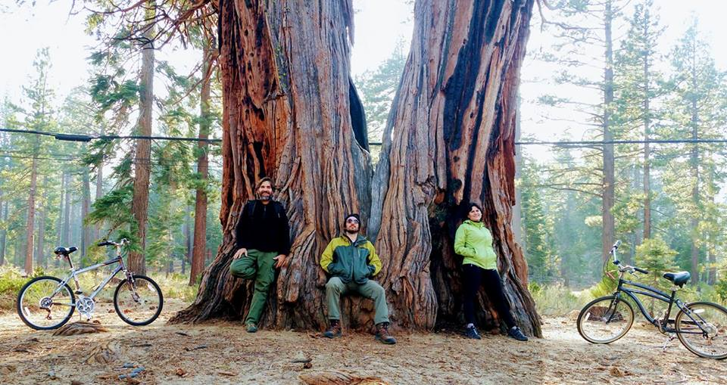
U.S. – BRAZIL EXCHANGE SHOWS EXPERIENCE WITH MULTIPURPOSE TRAILS IN PARKS AND WORK WITH VOLUNTEERS
Exchange programs have been on the agenda of the partnership between the US Forest Service and the Chico Mendes Institute for the Conservation of Biodiversity (ICMBio) for a long time. Under the “Trails Together” initiative, Brazilian managers of Protected Areas and the ICMBio Partnerships Coordinator, Carla Guaitaneli, spent two weeks in the United States learning about trail-related activities in Protected Areas, together with US Forest Service officials. These efforts are designed to help Brazil increase tourism to its protected areas. Trails Together, as the title suggests, brings ICMBio and USFS staff on “real world” multiple-use trail operations activities. On week 1, ICMBio participants worked alongside USFS trails experts to partially construct a bridge at Alice Lake Road (South Lake Tahoe) and learn about trail development and construction. On week two, participants learned from USFS partners and volunteers about trail inspection and maintenance, volunteer programs’ governance, communication and outreach, and how to engage communities for land stewardship activities. Participants also visited long-distance trails to learn about opportunities and challenges of multiple-use trails. Through the duration of the workshop, and as participants learn new concepts, USFS experts guided them in completing capstone trails and partnerships program projects currently under development in Brazil.
Photo: Carla Guaitaneli
The ICMBio participants came back full of ideas to implement in their projects and share with other managers. Carla Guaitaneli, the ICMBio Partnership Director, shared this testimonial about her experience:
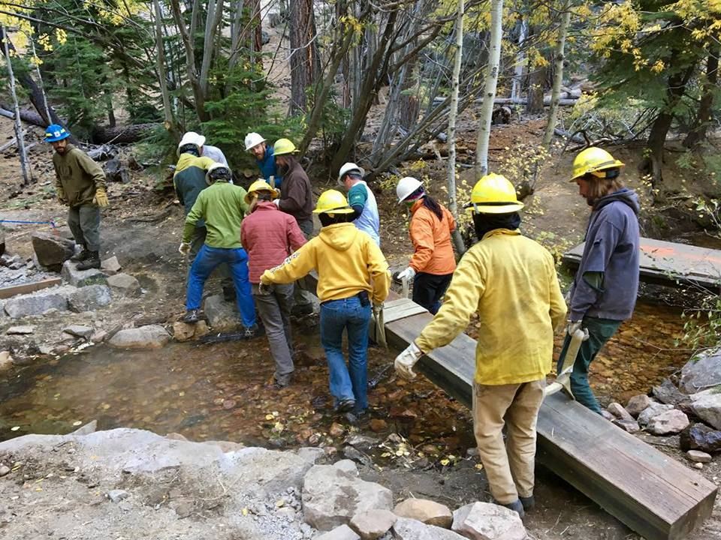
Photo: Carla Guaitaneli
“This is our second technical visit in partnership with the US Forest Service and USAID. Five ICMBio officials, including me, have come here to learn about volunteering, mountain bike trails, partnership strategies and engaging society for the protection of protected areas.
We have observed that the public here is really engaged in the maintenance of protected areas and the opening of new trails. People here in Salt Lake Tahoe use these protected areas a lot. It is really nice to find a park that is maintained with the support of volunteers, who organize themselves in groups, join efforts, plan the opening of new trails, and erect signs in urban parks listing the names of the main donors and volunteers. This engagement by society gives people ownership of the work developed by the Forest Service.”
Building a bridge

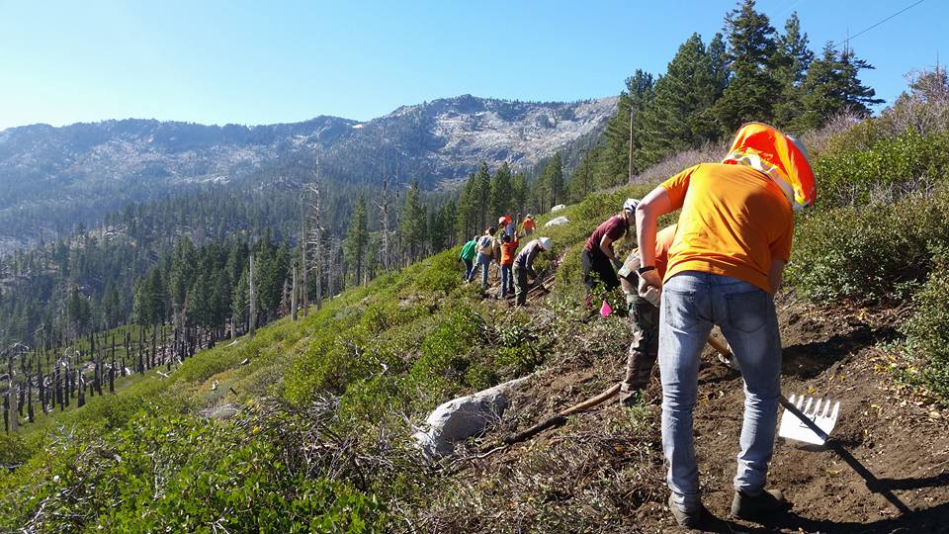
This week, we worked on the construction of a bridge over a trail with the USFS trail management team. Some of the volunteers had a very technical background, including carpenters. Today, we spent the day with a group of volunteers opening a new mountain bike trail, which has helped us understand the issue of leadership in a group of volunteers and their relationship with the USFS. This visit has focused on how they make society actively engage in the protection and development of Protected Areas.
Working on a mountain bike trail

Photo: Carla Guaitaneli
It has been fantastic because we have been able to understand how it works here, and visualize how it could be in Brazil, or at least to foresee the potential for it. It is a technical visit that we can actually put into practice. All but me are managers of Protected Areas that are planning to implement mountain bike trails. They have already taken some training in Brazil and developed technical projects. This technical visit follows a whole capacity building logic.”

THE USFS HOLDS MANAGEMENT PLANNING AND FACILITATION WORKSHOP WITH THE US NATIONAL PARK SERVICE
From 23-26 October, the USFS implemented a management planning and facilitation workshops, in partnership with the National Park Service, which took place at the Parque Nacional da Chapada dos Veadeiros and Brasília. The objective of the workshop was to share some of the key facilitation techniques and best practices related to building participation into management planning.

FIFTH ANNIVERSARY OF THE INDIGENOUS LAND MANAGEMENT POLICY
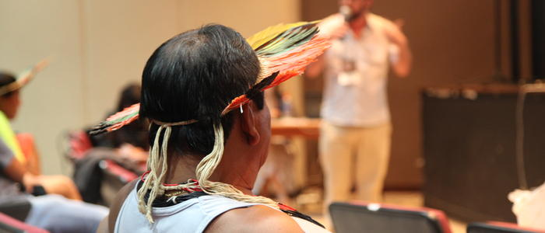
Indigenous and socioenvironmental organizations, together with National Indigenous Foundation (FUNAI) held a seminar in Brasilia to celebrate the fifth anniversary of the National Policy for the Territory and Environmental Management of Indigenous Lands (PNGATI). The Brazilian Education Institute (IEB), a local USAID Implementing Partner, supported the coordination of the event, which took place in early October.
Photo: Archive IEB
The seminar created a forum to discuss the challenges facing the implementation of the PNGATI in the Amazon at a time when government support is diminishing and the National Indigenous Foundation (FUNAI) has suffered severe budget cuts. According to Sonia Guajajara, Executive Secretary for the Coordination of Indigenous Peoples in Brazil (APIB), “our political context is very unfavorable toward the implementation [of the PNGATI policy] right now, and we lack funding and direct support”. Yet, she celebrated the process of having approved an Integrated Management Plan for PNGATI and a few Territory Management Plans.
The PNGATI is considered a model for engagement. Founded on indigenous advocacy and discussions brought forward by indigenous peoples and civil society, the policy was created in 2012 by a decree signed by the then President Dilma Rousseff.
Umanary Apurinã, is a tribal chief in the Camicuã Indigenous Land, in the southern area of the state of Amazonas. He has been participating in the PNGATI awareness raising exercises in the villages “so that people understand what it stands for, and how it was created”. This is one of the activities driven by Nossa Terra, the project supported by USAID and implemented by IEB in Southern Amazonas state. The Camicuã Indigenous Land has advanced with its the ethnic territorial mapping and is awaiting recognition at municipal and state level. “They do not recognize how serious our work is”, explains Umanary, who believes that local and state governments do not provide resources because they do not understand the extensive work that is required to develop a Territory Management Plan.
The municipality of Boca do Acre, where Camicuã is located, has the third largest cattle herd in the state. During the mapping of that Indigenous Territory, three more sustainable value chains were identified: Brazil nuts, cocoa, and açaí berry. The most distant villages within Camicuã, which hosts nearly 3,000 indigenous people, are those with the highest potential. They are located 12 to 24 hours by boat from the town of Boca do Acre.
Besides trying to attract the attention of public authorities to the economic potential offered by Camicuã and the strengths of Territory Management Plans, the main problems they face are invasions from outsiders and illegal timbering, hunting and fishing.
Francisco de Souza Jamamadi lives at the border between the states of Amazonas and Acre, in a village within an Extractive Reserve (Aripixi). In 2016, with the support of the IEB, indigenous people and those involved in extractive activities developed an integrated Territory Management plan, which has not yet been formally approved. Umanary and Francisco believe that the next step to further develop these value chains, will be to access markets and adjust the role of intermediaries. USAID-funded projects are working to strengthen these kinds of activities in several indigenous territories across the Amazon.
For the full text of the PNGATI Fifth Anniversary Seminar final document, please click here (in Portuguese).

RECENT AND UPCOMING EVENTS
- The Mais Unidos Corporate Social Investment Group annual board meeting took place on October 19 in Sao Paolo.

- The second module of the FORMAR Castanha (Brazil nut) Training Program, coordinated by the Brazilian Education Institute (IEB) with the participation of other partners in the PCAB Value Chain initiative is taking place October 30 - November 10. Venue: Novo Airão (Manaus) - Fundação Vitoria Amazônica

- The Third Seminar on Good Practices for the Management of Protected Areas and the 1st International Forum on Partnerships for the Management of Protected Areas coordinated by the USFS, will take place November 27 to November 29. Venue: Centro Internacional de Convenções do Brasil (CICB), Setor de Clubes Esportivos, Trecho 2, Conjunto 63, Lote 50, Brasília/DF

- Native Amazon Operation (OPAN), a partner of the IEB, will hold three meetings to validate the Pirarucu value chain (sustainable fisheries) in the state of Amazonas in November. The first of such meetings took place in late October.

- The USFS will hold its Third Annual Partner meeting, bringing together diverse partners, sub-partners, and consortium members December 5-6 in Brasilia at the Centro Cultural de Brasília.

- USAID/ Brazil will officially launch the Partnership Platform for the Amazon (PPAM) December 6-7 in Manaus, Amazonas State with the participation of Sarah-Ann Lynch, Acting Assistant Administrator for Latin America & Caribbean Bureau; U.S. Ambassador to Brazil, P. Michael McKinley, and business leaders from the Amazon and throughout the region, plus other key biodiversity partners.

For those who have interest to see previous issues of USAID/Brazil’s reports, please visit the following page: https://pages.usaid.gov/brazil/bi-weekly-reports

